**PRACTICAL NO :3**

Install Selenium Server (Selenium RC) and demonstrate its usage by executing a script in Java or PHP to automate browser actions

Click on File then Click New Project:

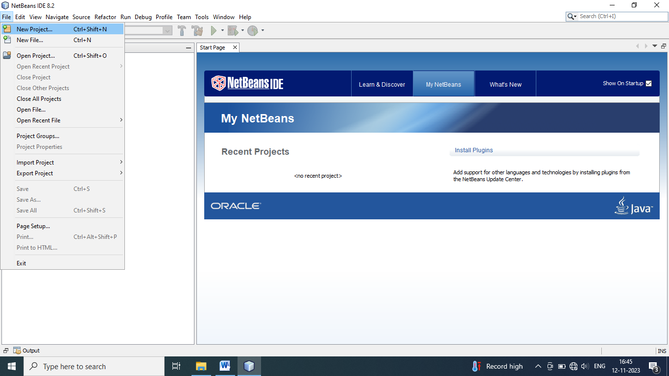

Select Java and Java Application Then Click on Next Button:

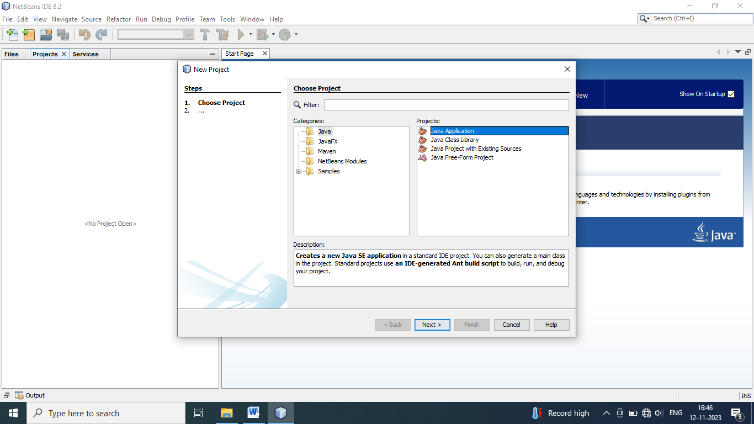

Give Project Name And Project Location And Click Finish Button:

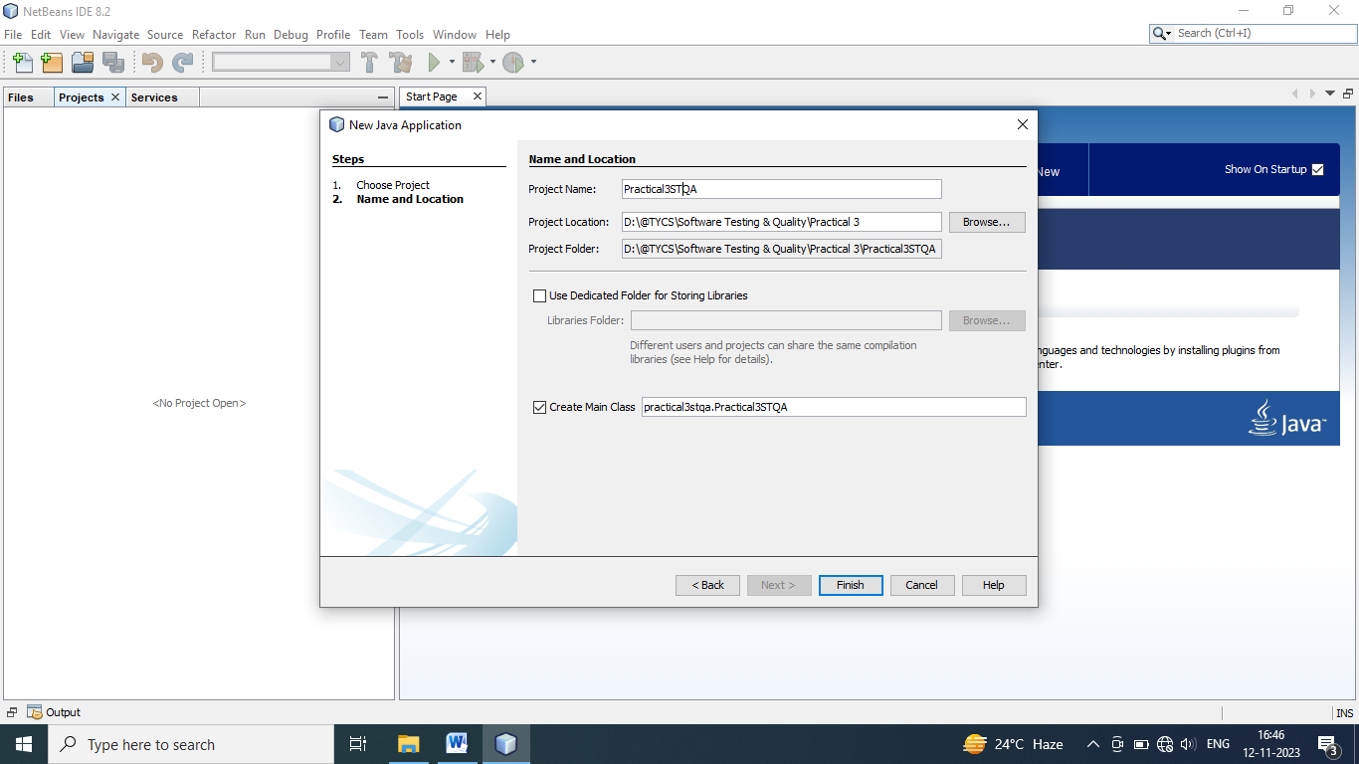

Creating New Project Start :

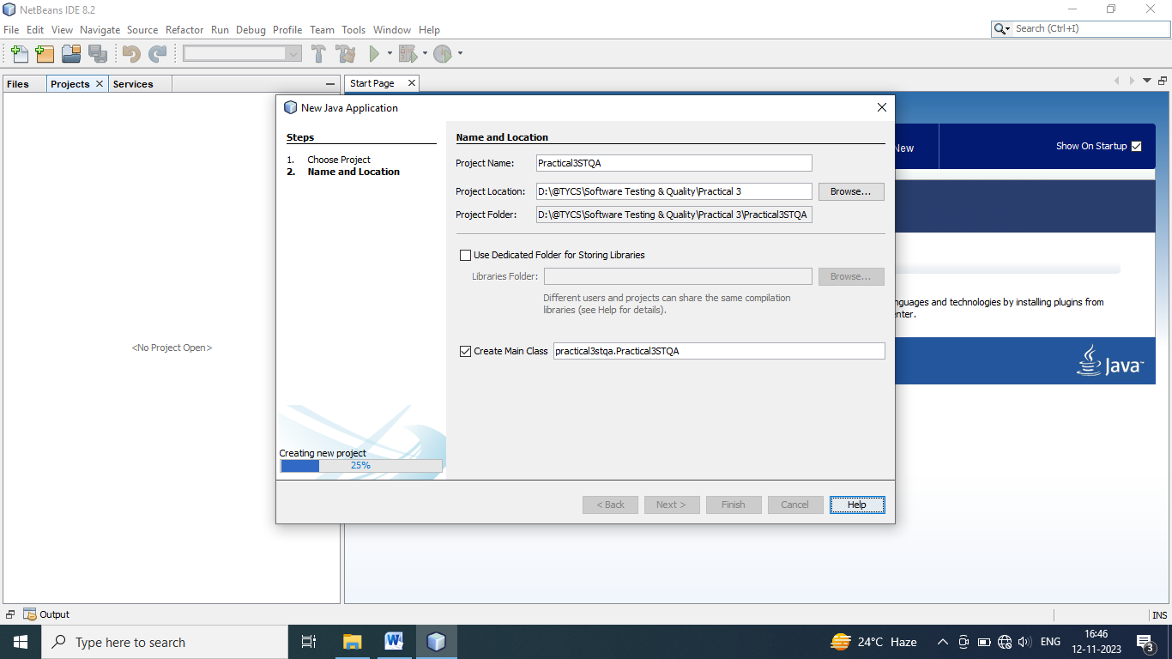

Copy Driver Folder

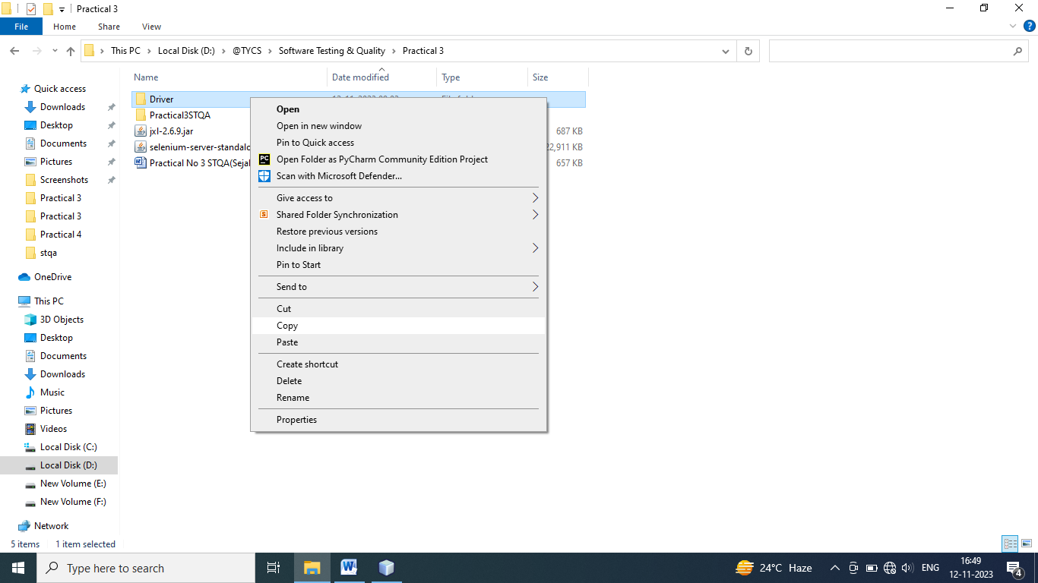

Paste is in Source Packages :

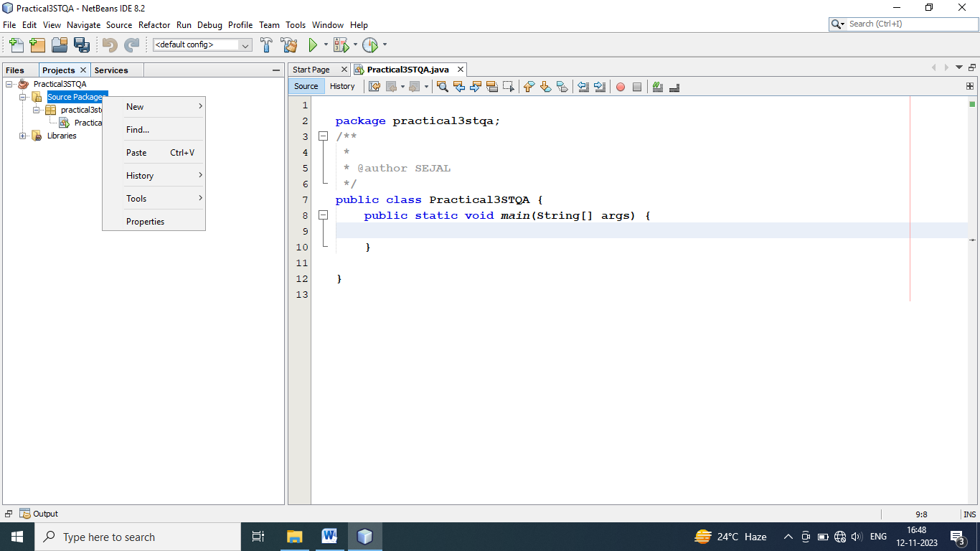

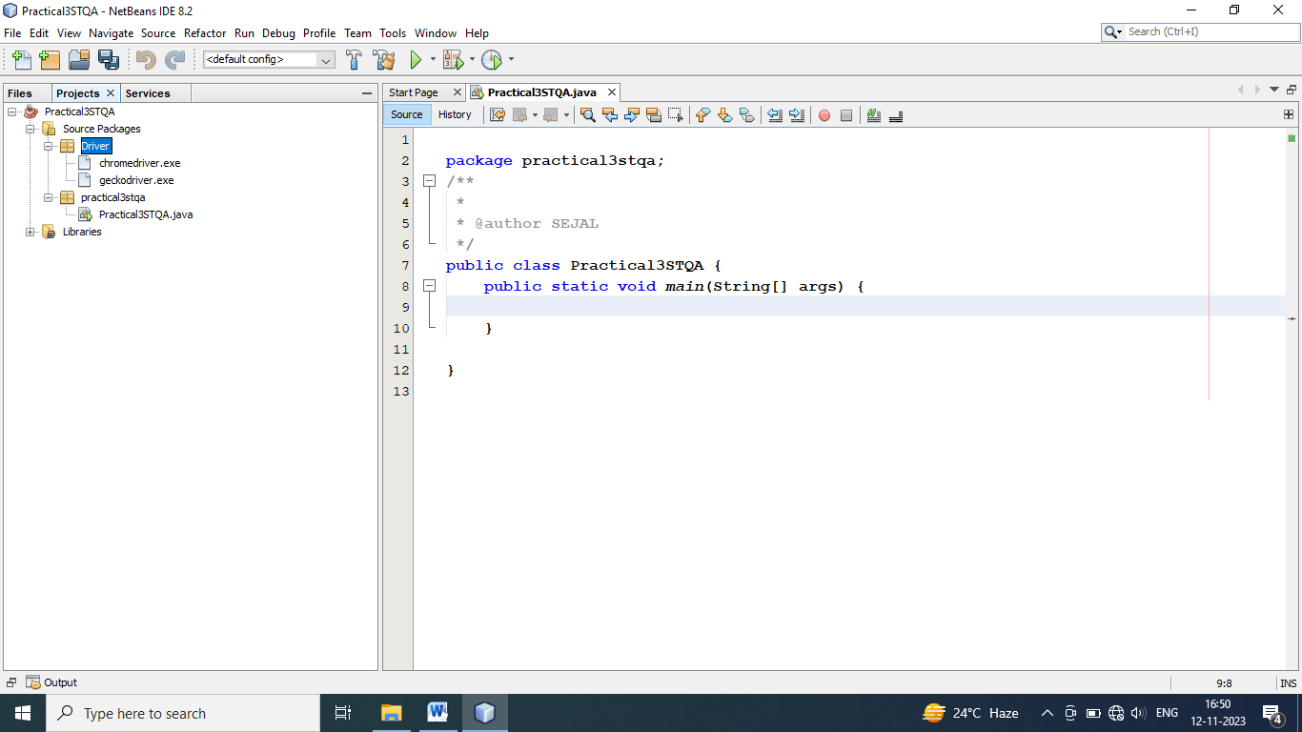

Right click on Libraries :

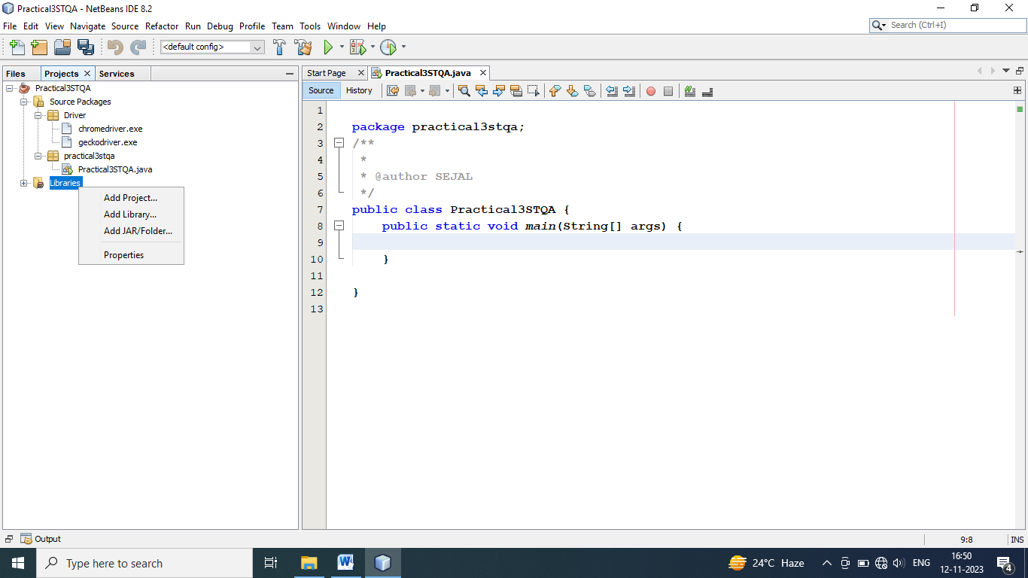

Then Click On Add JAR /Folder

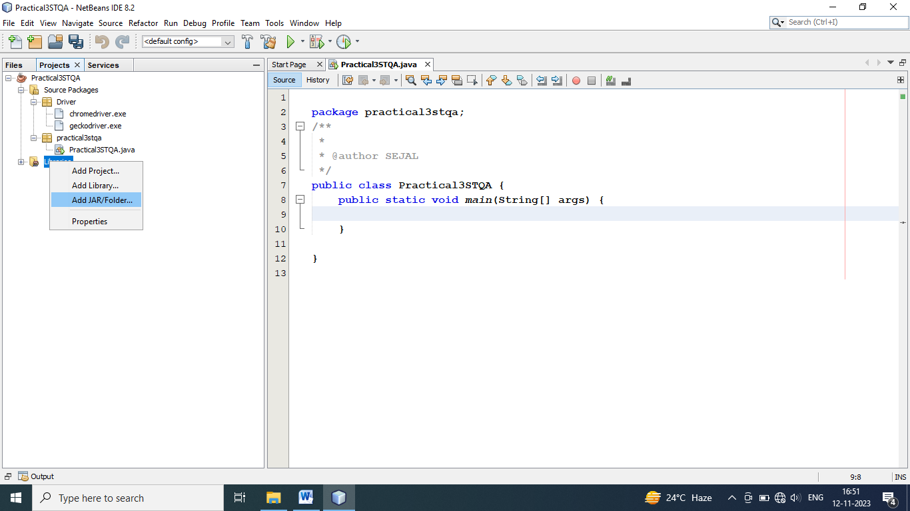

Give Path of jar and Click open: 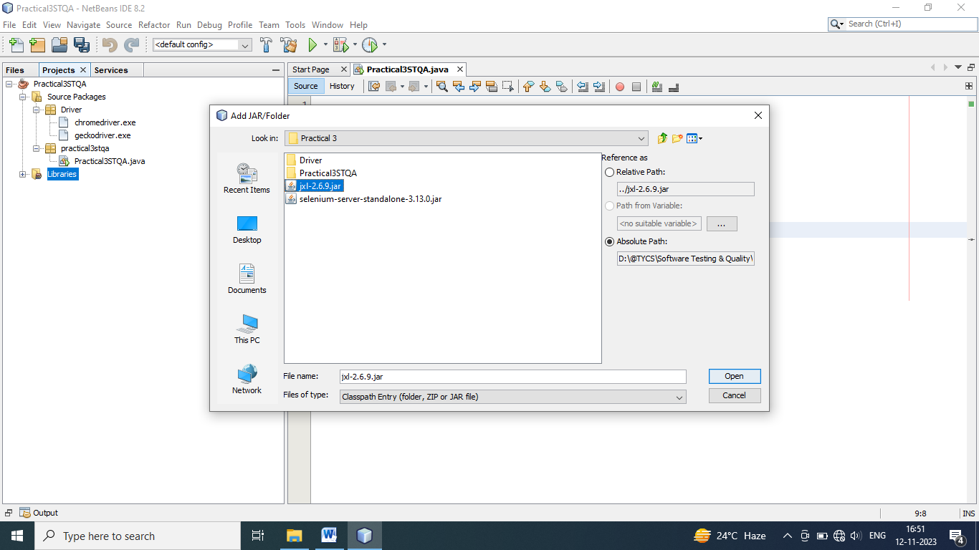

Right click on Libraries 

Then Click On Add JAR /Folder :



Give Path of Selenium Server and Click open:

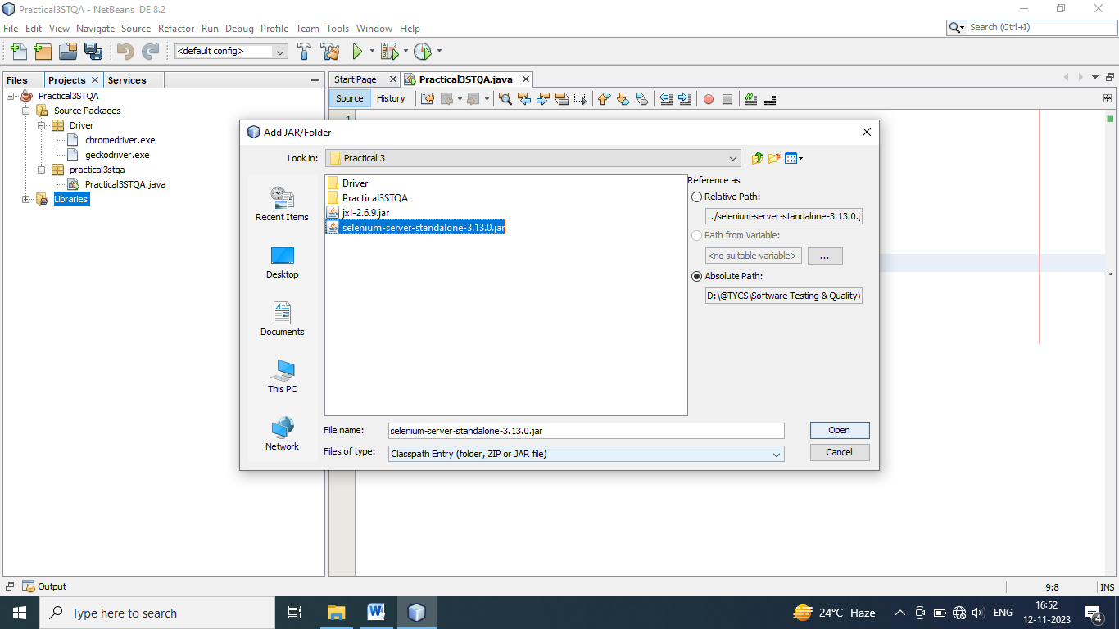

* **Input :**

**Code For Login.html File :**

<!DOCTYPE html>

<html>

<head>

<title>Login Page</title>

<style>

body {

font-family: Time news roman, sans-serif;

}

.container {

width: 300px;

margin: 0 auto;

padding: 20px;

border: 1px solid #ccc;

border-radius: 5px;

}

.container h2 {

text-align: center;

}

.container input[type="text"],

.container input[type="password"] {

width: 100%;

padding: 12px 20px;

margin: 8px 0;

display: inline-block;

border: 1px solid #ccc;

box-sizing: border-box;

border-radius: 4px;

}

.container button {

background-color: Blue;

color: white;

padding: 14px 20px;

margin: 8px 0;

border: none;

cursor: pointer;

width: 100%;

border-radius: 4px;

}

.container button:hover {

background-color: Blue;

}

</style>

</head>

<body>

<div class="container">

<h1><center><b>Login</center></b></h1><br>

<label for="username"><b>Username:</b></label>

<input type="text" id="username" name="username" required>

<label for="password"><b>Password:</b></label>

<input type="password" id="password" name="password" required>

<button type="submit" id="submit" name="submit"><b>Login<b></button>

</form>

</div>

</body>

</html>

* **Code in NetBeans:**

package practical3stqa;

import org.openqa.selenium.By;

import org.openqa.selenium.WebDriver;

import org.openqa.selenium.firefox.FirefoxDriver;

/**

*

* @author SEJAL

*/

public class Practical3STQA {

public static void main(String[] args) {

System.setProperty("webdriver.gecko.driver","D:\\@TYCS\\Software Testing & Quality\\Practical 3\\Practical3STQA\\src\\Driver\\geckodriver.exe");

WebDriver driver = new FirefoxDriver();

driver.get("http://localhost///Sejal%20Sawant/@TYCS/Practical%203/Login.html");

driver.findElement(By.name("username")).sendKeys("Sejal");

driver.findElement(By.name("password")).sendKeys("Sejal12");

}

}

* **Output :**

